Software Requirement Specification

Online Shopping

Table of Content

1. Abstract 3

2. Functional Requirements 4

3. Non-Functional Requirements 5

3.1. Performance 5

3.2. Reliability 5

3.3. Scalability 5

3.4. Security 5

3.5. Compatibility 5

3.6. Maintainability 5

4. Design 6

4.1. Low-level design 6

4.2. High-level design 7

5. Flow Diagram 8

6. Use-case Diagram 9

7. Class Diagram 10

8. Sequential Diagram 11

9.Test Cases 12

**1. ABSTRACT**

In today's world, shopping online has become a big deal. It's changed how we shop and how businesses sell their stuff. This paper looks at online shopping from all angles, talking about how it started, how it's changed our lives, the problems it faces, and what the future might hold. Online shopping became a thing when the internet showed up. Now, with websites and apps, people can buy almost anything without leaving their homes. No more waiting in lines or rushing to get to stores before they close. Instead, you can shop whenever you want and have things delivered right to your door. Websites know what you like, so they can suggest stuff you might want to buy, making shopping even easier. It's not just about convenience, though. Online shopping lets small businesses reach customers all over the world. This means more people can buy their products, which helps these businesses grow and creates jobs. And with cool technologies like virtual reality, shopping online can feel almost like being in a real store.

**2. FUNCTIONAL REQUIREMENTS**  
 Functional requirements for an online shopping system typically include the following aspects:

**2.1 User Registration and Authentication:**

* Users should be able to create accounts, log in, and log out securely.
* Password recovery mechanisms should be in place.

**2.2 Product Browsing:**

* Users should be able to browse products by categories, and brands, or search for specific items.
* Product pages should display detailed information, including images, descriptions, prices, and availability status.

**2.3 Shopping Cart:**

* Users should be able to add items to their shopping carts, update quantities, and remove items.
* The shopping cart should display the total cost and allow users to proceed to checkout.

**2.4 Checkout Process:**

* Users should be guided through a seamless checkout process, including providing shipping and billing information.
* Multiple payment options (e.g., credit card, PayPal, etc.) should be supported.
* Users should receive confirmation of their orders through email or on-screen notification.

**2.5 Search and Filtering:**

* Users should be able to easily find products through filtering options (e.g., by price range, size, colour, etc.).

**2.6 Order Management:**

* Users should be able to view their order history and track the status of their orders. Administrators should have access to manage orders, process payments, and update order statuses.

**3. Non-Functional Requirement**

Non-functional requirements define the attributes that describe the system's operation, rather than specific behaviors.

**3.1 Performance:**

* The system should respond quickly to user actions, with minimal loading times for pages and processes.
* It should be able to handle a large number of concurrent users without significant degradation in performance.

**3.2 Reliability:**

* The system should be available and accessible to users anytime, with minimal downtime for maintenance or upgrades.

**3.3 Scalability:**

* The system should be able to scale up to accommodate increasing numbers of users, transactions, and products.

**3.4 Security:**

* The system should implement strong authentication and authorization mechanisms to prevent unauthorized access.

**3.5 Compatibility:**

* The system should be compatible with a wide range of web browsers and devices, including desktops, laptops, tablets, and smartphones.
* It should support multiple operating systems and screen resolutions.

**3.6 Maintainability:**

* The system should be modular and well-structured, allowing for easy maintenance, updates, and enhancements

**4. DESIGN**

**4.1 LOW-LEVEL DESIGN**

A low-level design for an online shopping platform involves detailing the system architecture, database schema, and interactions between various components.

**4.1.1 System Architecture:**

* Frontend: The user interface where customers interact with the platform.
* Backend: The server-side logic is responsible for processing requests, handling business logic, and interacting with the database.

**4.1.2 Database Schema:**

* User Table: Stores user information such as username, email, password hash, shipping addresses, and payment methods.
* Product Table: Contains details about products such as ID, name, description, price, quantity available, and category.

**4.1.3 Components and Interactions:**

* User Authentication: When a user logs in or registers, the frontend sends a request to the backend.
* Adding to Cart: When a user adds a product to their cart, the frontend sends a request to the backend, which updates the cart in the database.
* Order Management: Users can view their order history, which involves querying the database for orders associated with their user ID.

**4.1.4 Error Handling:**

* Implement error handling mechanisms to gracefully handle exceptions and provide informative error messages to users.
* Log errors and exceptions for debugging and monitoring purposes.
  1. **HIGH-LEVEL DESIGN**
* **Product Pages:** Each product has its own page. It's like picking up an item in a store to look at it closely. On the page, you can see pictures, read descriptions, and check the price.
* **Shopping Cart:** Imagine a digital shopping basket. As you browse the store and find things you want to buy, you add them to your cart. It keeps track of everything you're planning to purchase.
* **Checkout Counter:** When you're done shopping, you go to the checkout counter. This is where you review your cart, enter your payment and shipping information, and complete your purchase.
* **Payment Processing:** Once you've entered your payment details, the system securely processes your payment. It's like paying at the cashier in a store, but everything happens digitally.
* **Order Confirmation:** After your payment is processed, you get a confirmation. It's like getting a receipt that shows you what you've bought, how much you've paid, and when your items will be delivered.
* **User Accounts:** You can create an account to make shopping easier next time. It stores your information, like your address and payment details, so you don't have to enter them every time you shop.
* **Security:** Shopping online is safe. The website uses special technology to protect your personal and payment information. You'll often see a little lock icon in your browser to show that it's secure.
* **Reviews and Ratings:** Just like asking a friend for advice, you can read reviews from other shoppers. They share their experiences with products, which can help you decide what to buy.

**5. FLOW DIAGRAM**

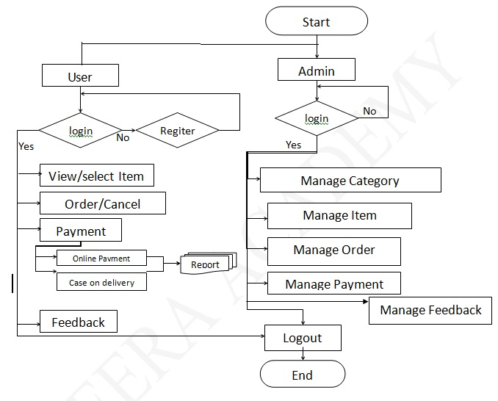

5.1 Flow Diagram

**6. USE-CASE DIAGRAM**

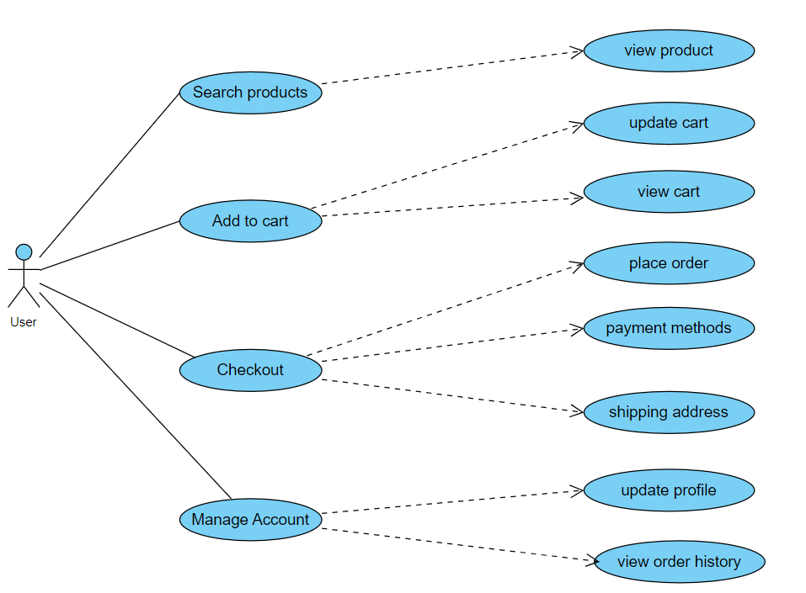

4.1 Use-case diagram

**7. CLASS DIAGRAM**

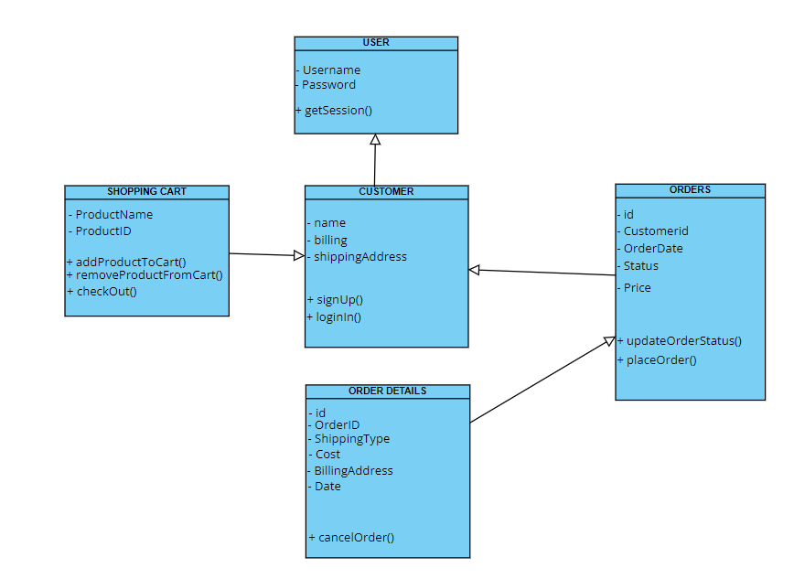

7.1 Class Diagram

**8. SEQUENCE DIAGRAM**

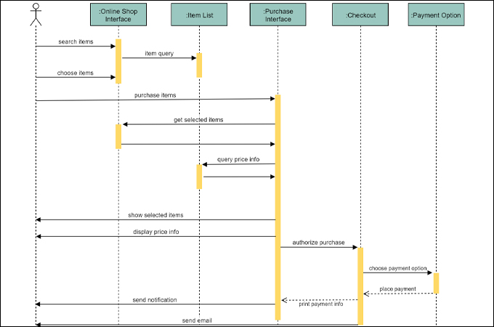

8.1 Sequential Diagram

**9. TEST CASES**

**9.1 User Registration and Login:**

* Verify that users can successfully register with valid information.
* Verify that users cannot register with invalid or incomplete information.
* Verify that registered users can log in with correct and incorrect credentials.

**9.2 Wishlist Functionality:**

* Verify that users can add products to a Wishlist for future purchase.
* Verify that users can move items from the Wishlist to the shopping cart and increase the quantity in the Wishlist.
* Verify that users can remove items from the Wishlist.

**9.3 Product Reviews and Ratings:**

* Verify that users can leave reviews and ratings for products they have purchased.
* Verify that reviews and ratings are displayed correctly on product pages.
* Verify that users can filter products based on ratings.

**9.4 Shipping and Delivery:**

* Verify that users can select different shipping addresses for orders.
* Verify that estimated delivery dates are displayed accurately during checkout.
* Verify that users receive shipping confirmation emails with tracking information.
* Verify that users can contact customer support for assistance with delivery issues.

**9.5 Returns and Refunds:**

* Verify that users can initiate returns for products they are unsatisfied with.
* Verify that users can request refunds for returned items.
* Verify that users receive confirmation emails for return requests and refunds processed.

**9.6 Payment Processing:**

* Verify that users can choose from multiple payment methods